**Homework 9**

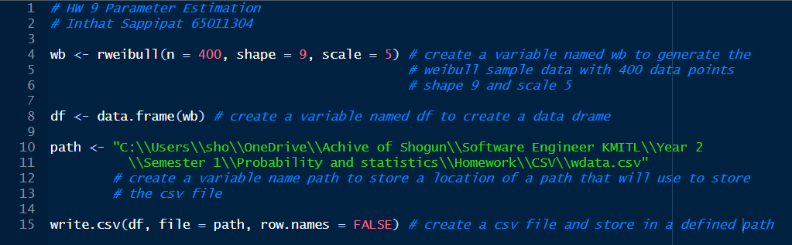**Code:**

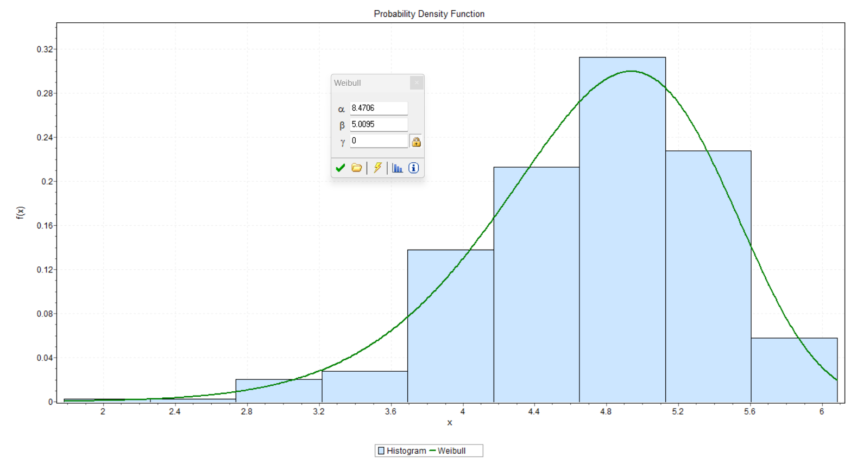**Result:**

**Conclusion:**

From the experiment, I have created a histogram of sample data by using RStudio and Easyfit. First, I created a code to generate a sample Weibull data with 400 data points, a shape parameter of 9, and a scale parameter of 5. Next, I make a file path to save a CSV file when running a R code, it will save to the location that I defined. Then, I opened the Easyfit application and opened the saved file from the defined location. Finally, I used the analyze tool to show the bar graph and show the scale and shape. In my opinion, the parameter from the experiment is quite close to the real parameter, on the other hand, the real parameter of shape is 9 and the scale is 5, and the experiment parameter of shape is 8.4706 and the scale is 5.0095. Therefore, it has a high accuracy.